Assignment 5

**Task 9-**

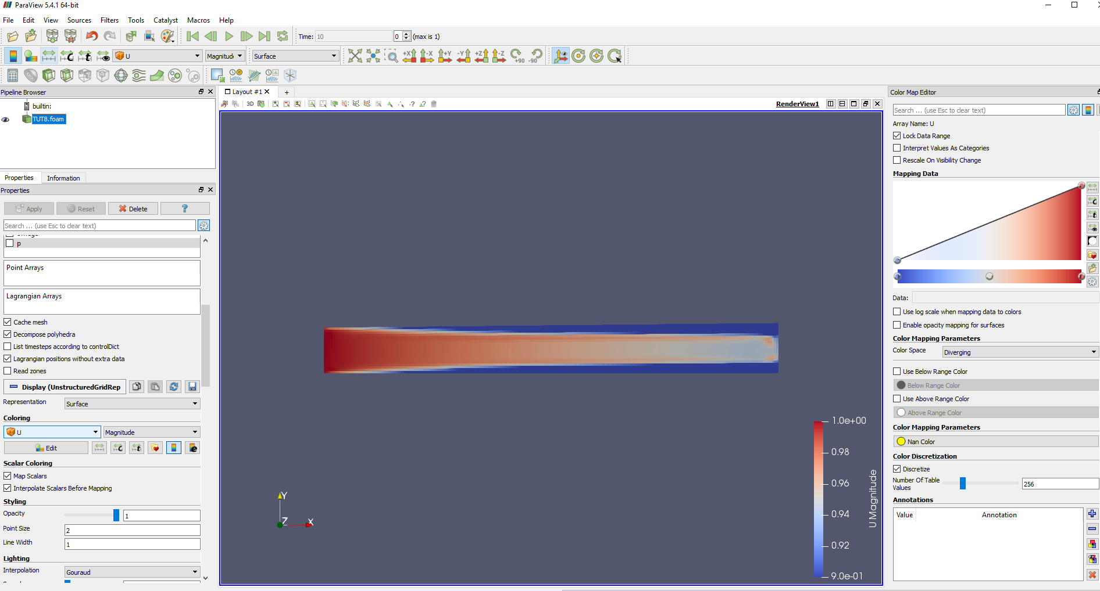

Figure 1 - After 10 iterations

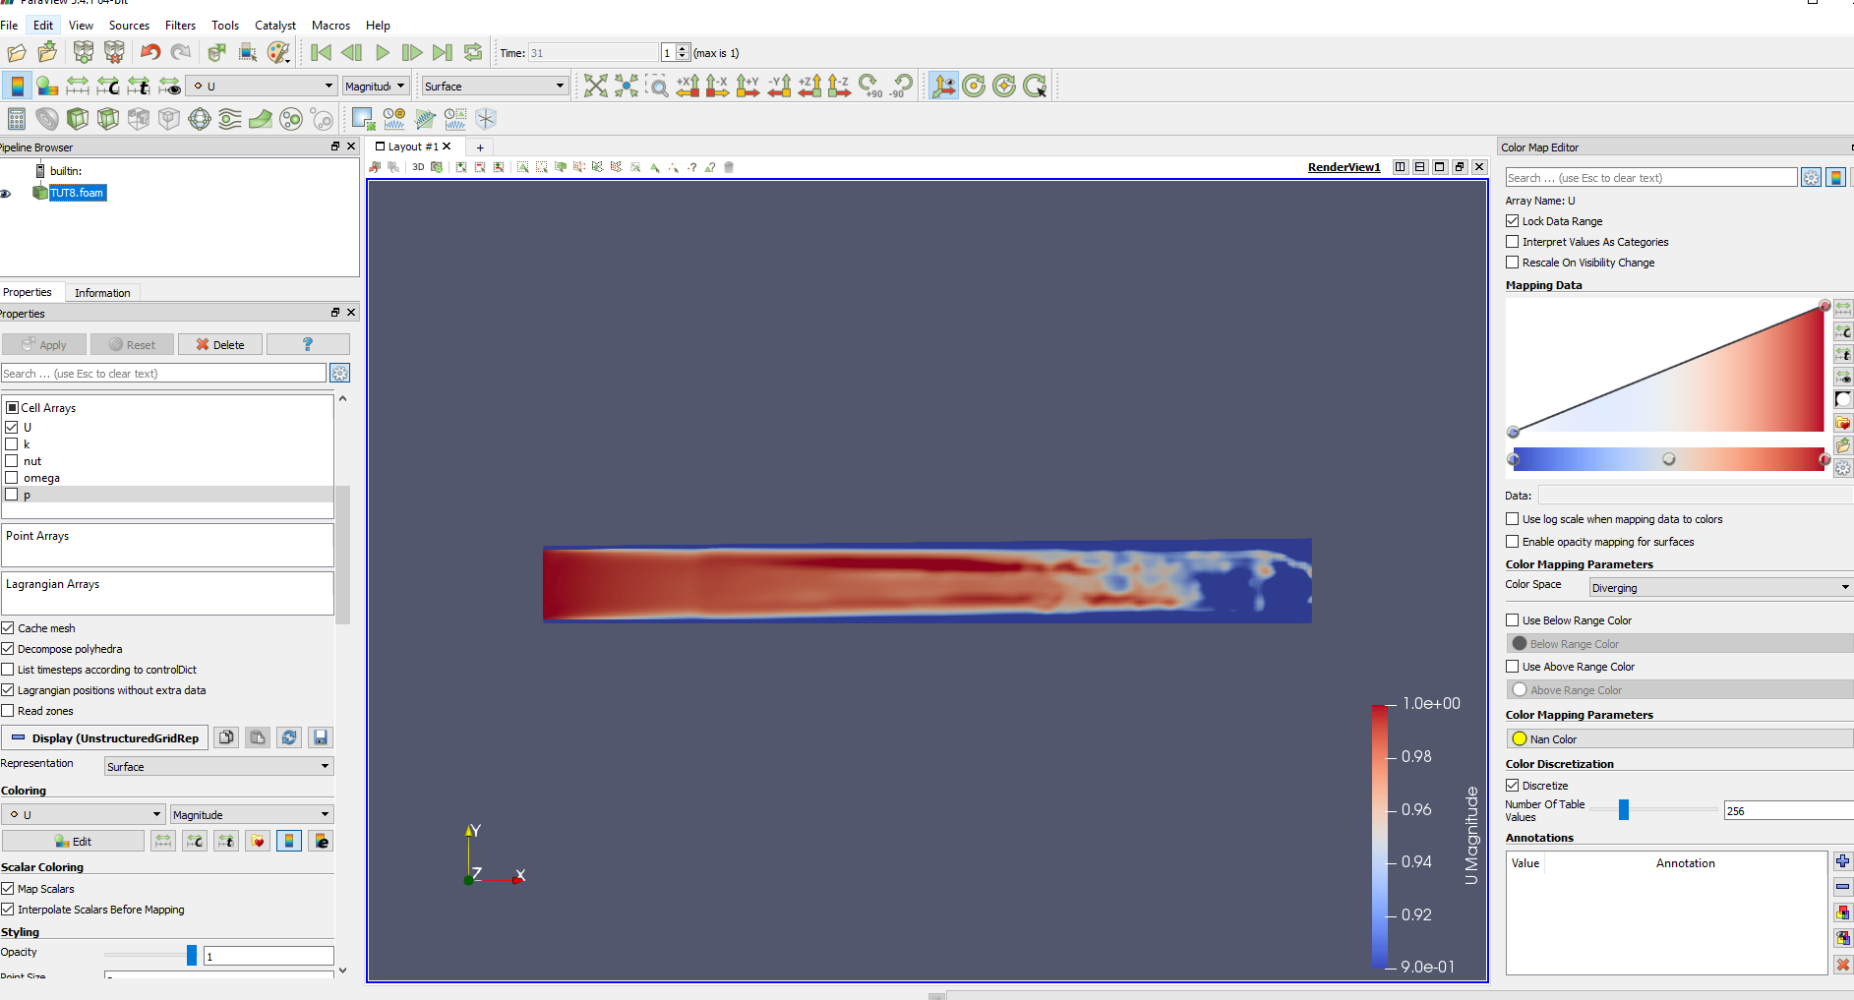

Figure 2 - After 0.1 Convergence

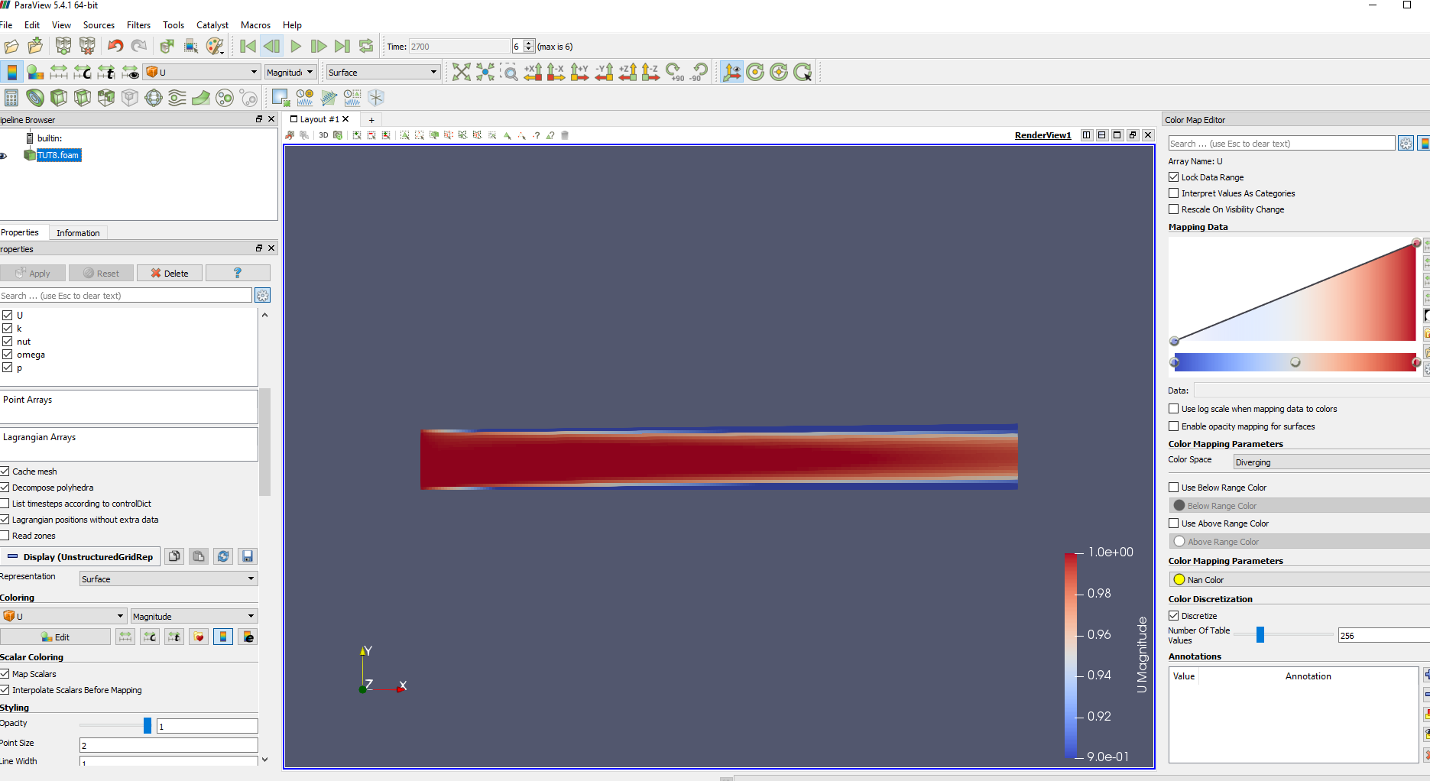

Figure 3 - After 0.001 Convergence

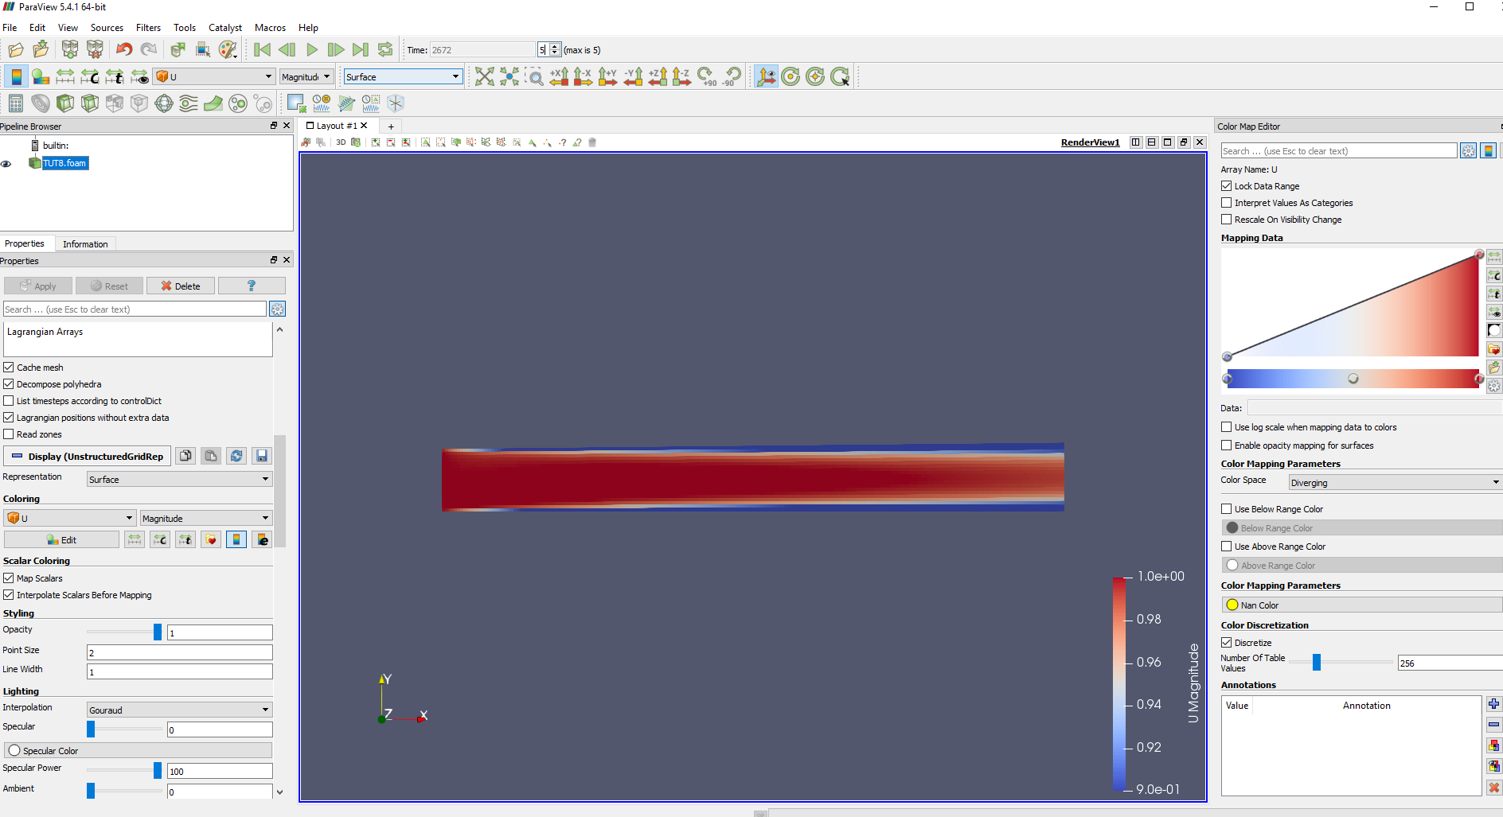

Figure 4 - After fvSolution Convergence

**Task 10-**

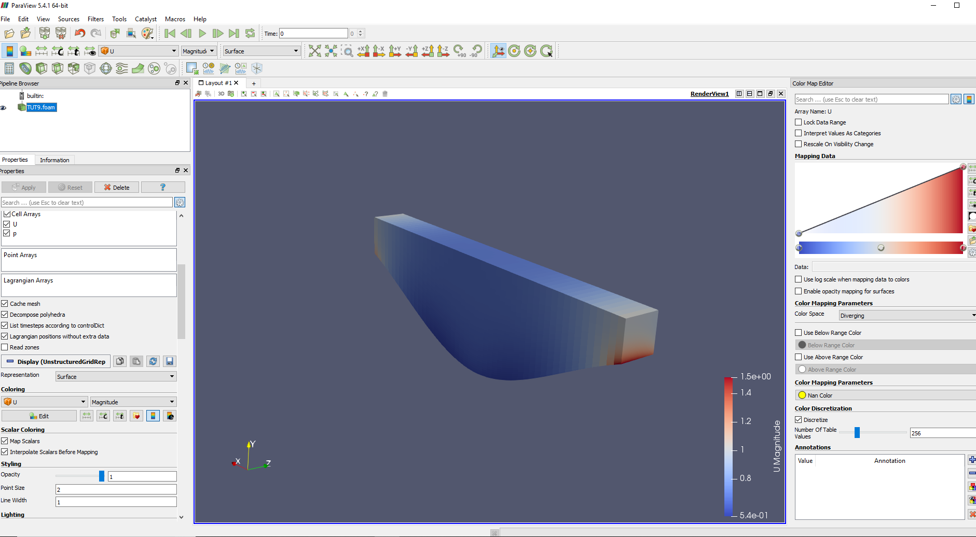

Figure 5 - 3D Velocity Profile with Spline

**Task 11-**

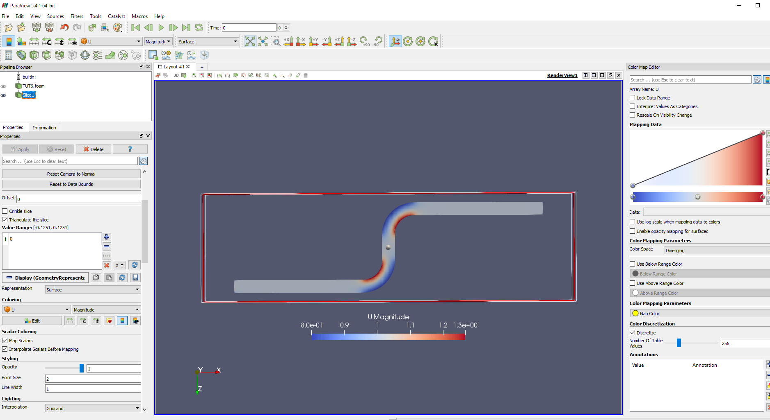

Figure 6 - Velocity Profile of the Pipe showing Corner Velocities

**Task 12-**

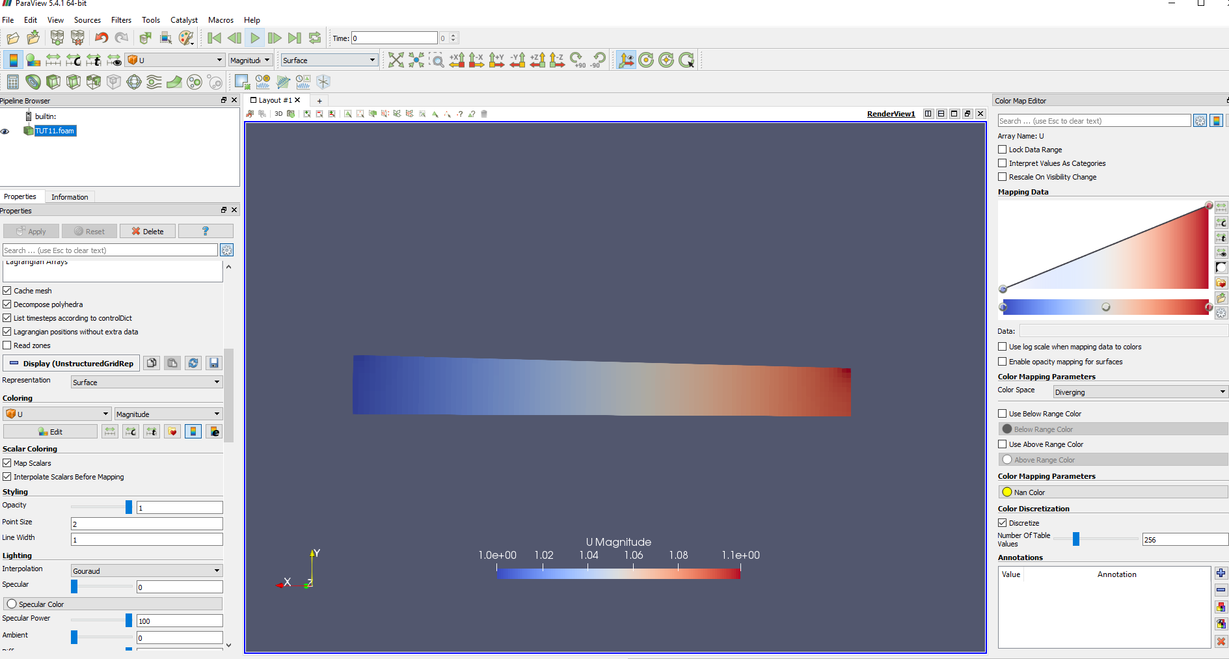

Figure 7 - Modified Velocity Profile without changing k BC

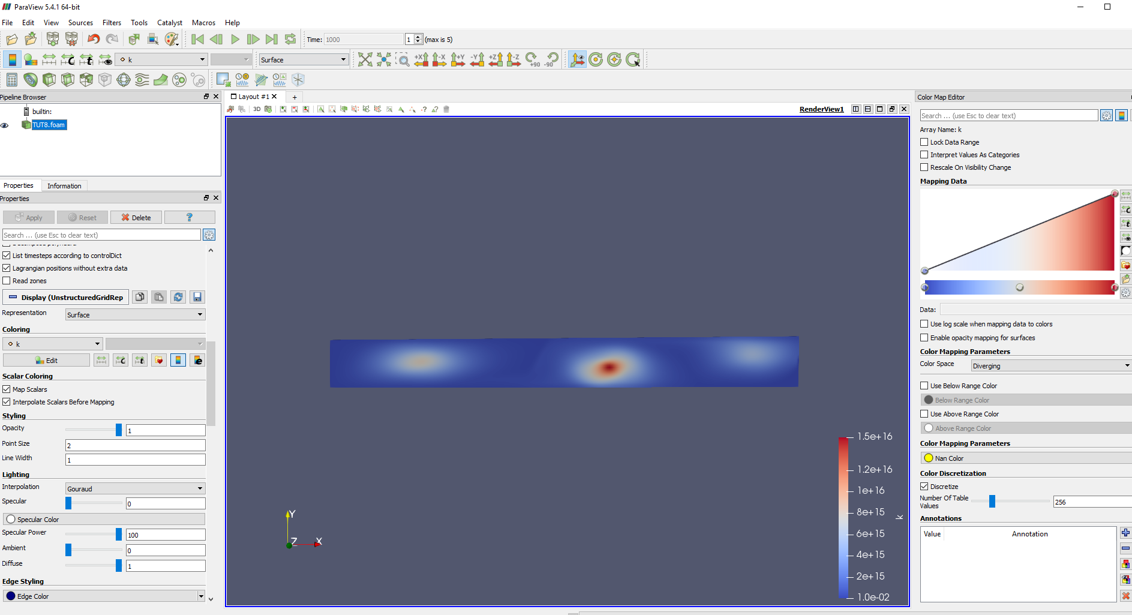

Figure 8 - Very High k-value profile

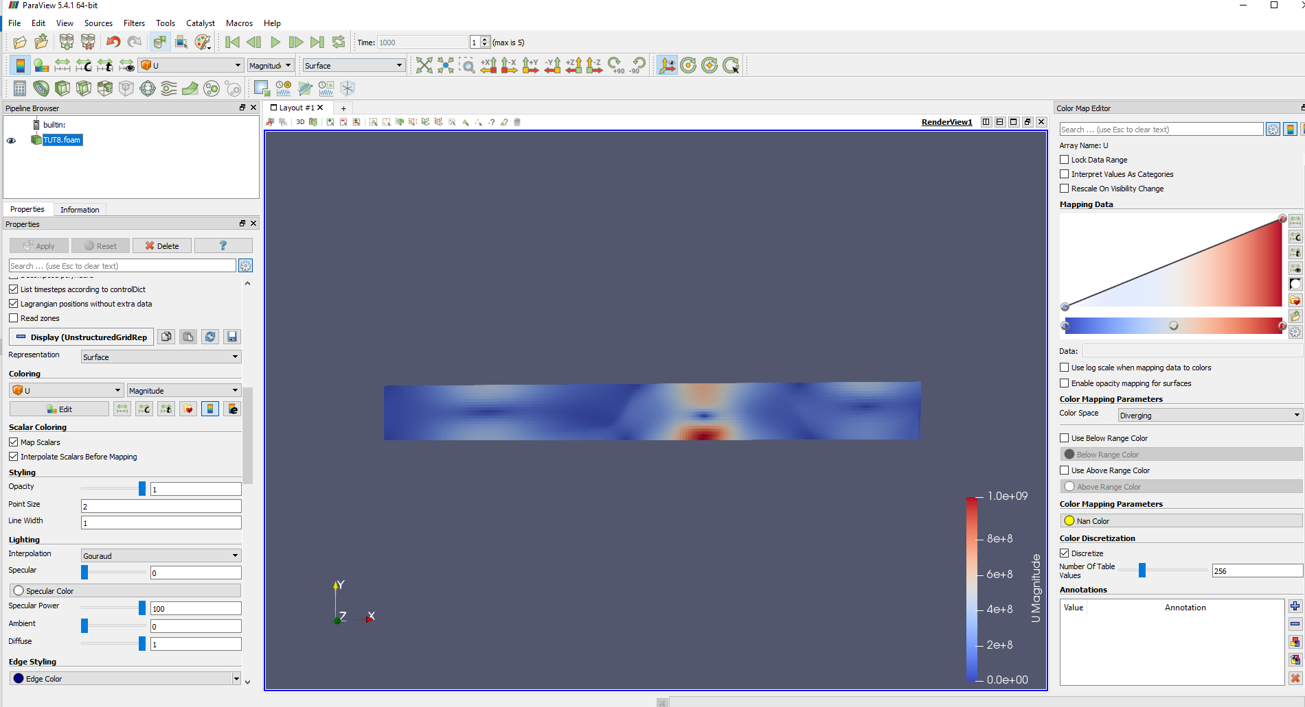

Figure 9 - Velocity profile with a very high k-value

**Task 13-**

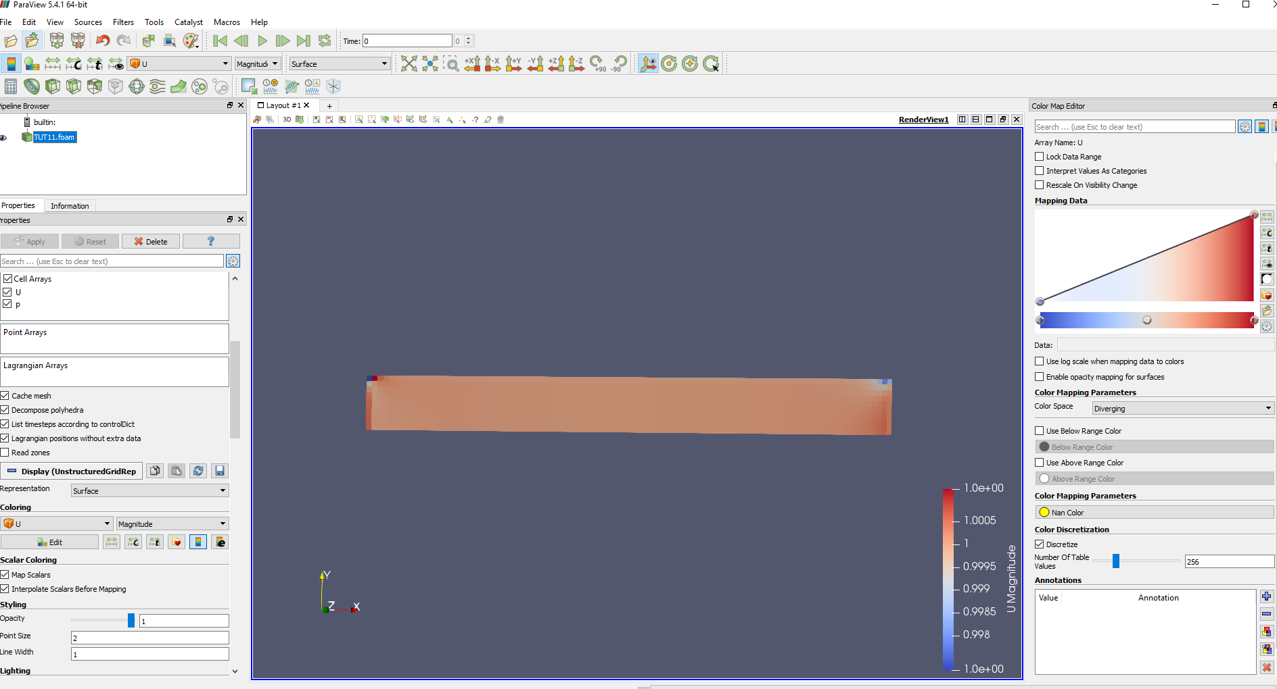

Figure 10 - Velocity profile with a moving wall boundary condition

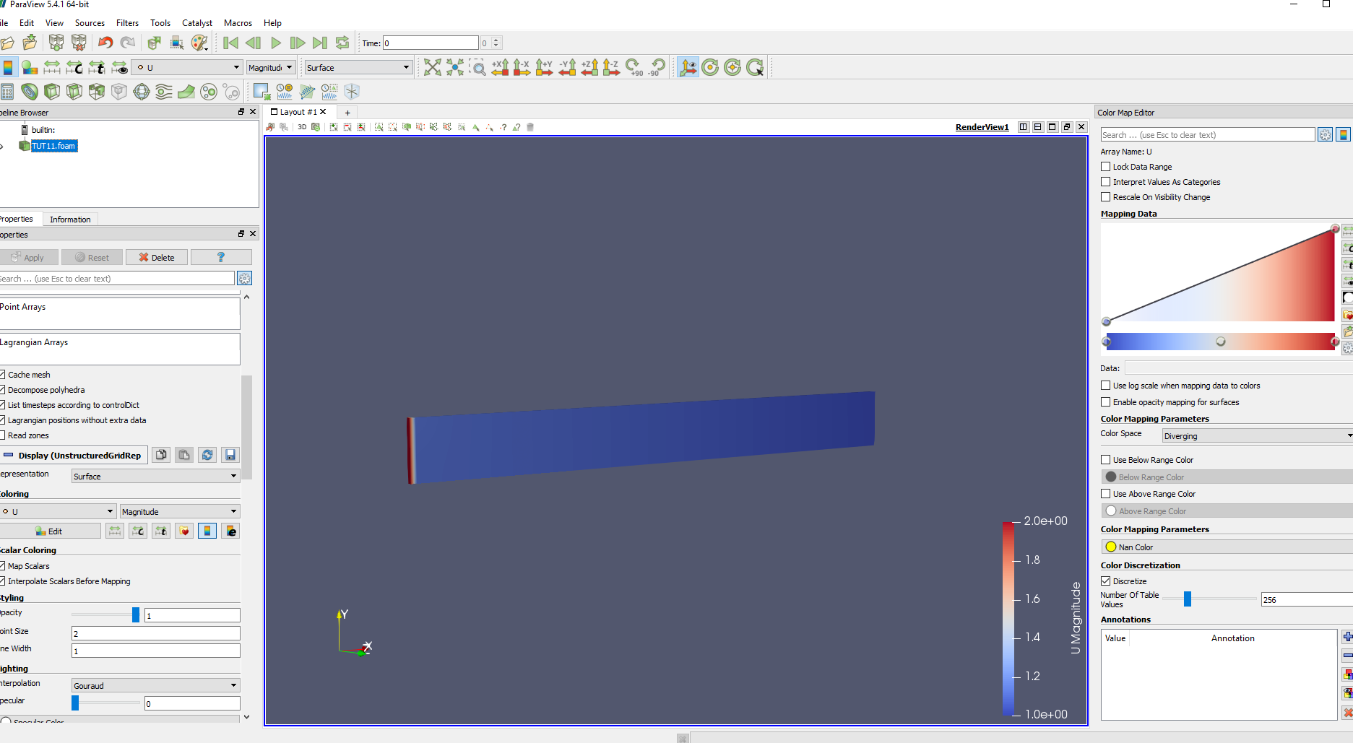

Figure 11 - Velocity profile with a symmetry boundary condition

**Additional Task 1-**

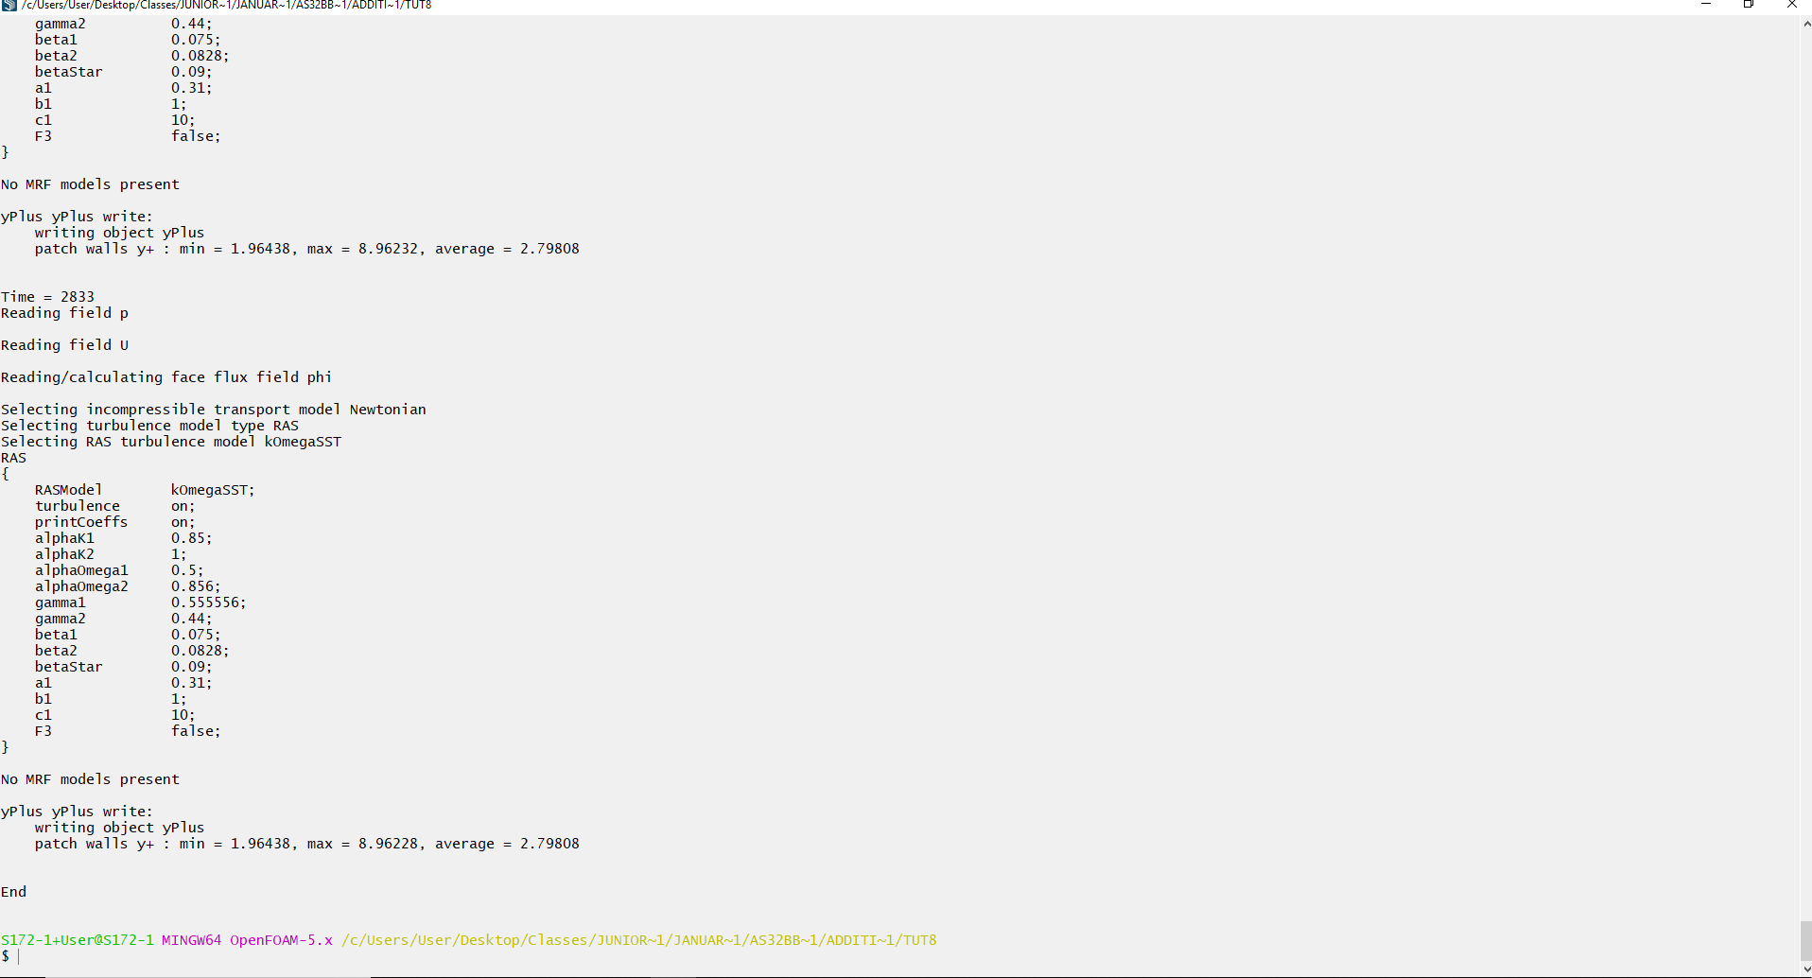

Figure 12 - yPlusMax data shown at the bottom

**Additional Task 2-**

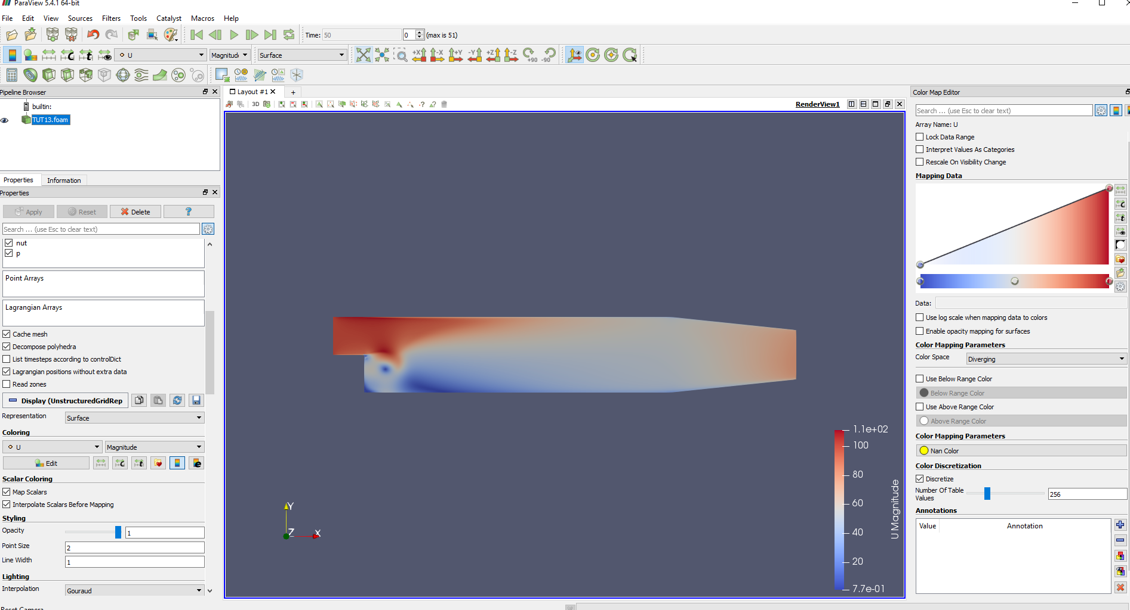

Figure - Simulation with turbulence and recirculation zone, time 1

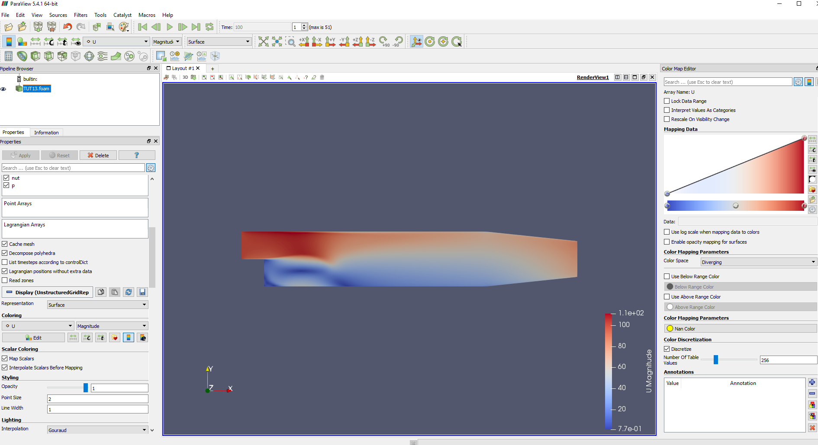

Figure - Simulation with turbulence and recirculation zone, time 2

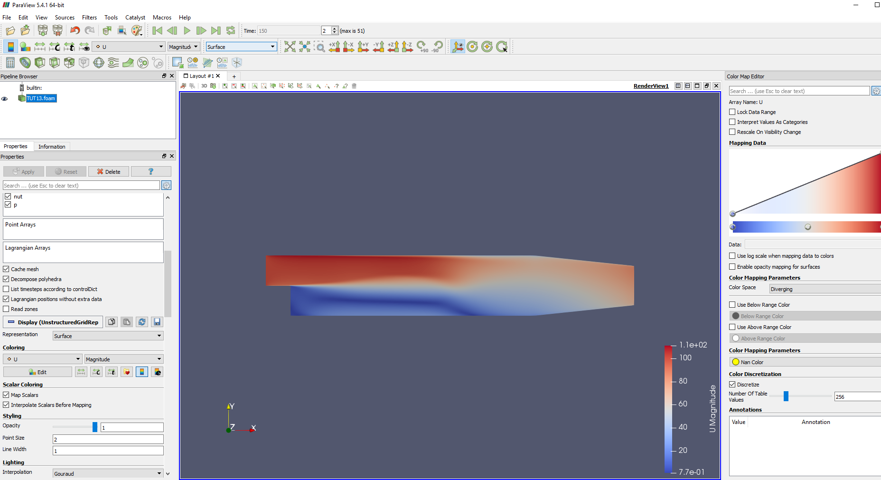

Figure - Simulation with turbulence and recirculation zone, time 3

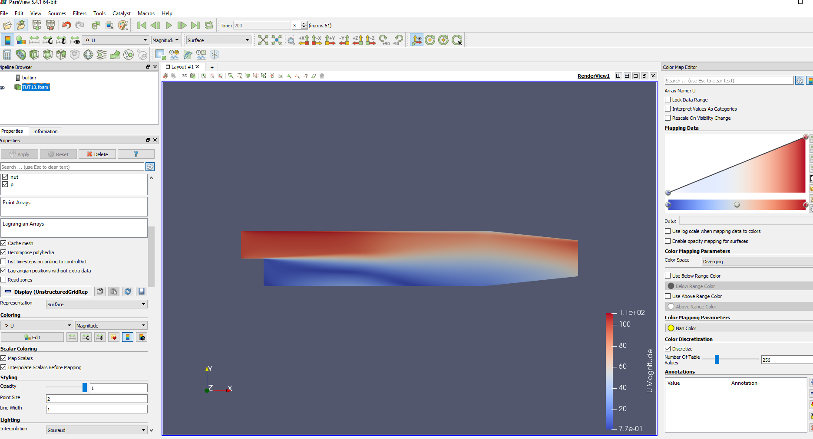

Figure - Simulation with turbulence and recirculation zone, time 4

**Additional Task 3-**

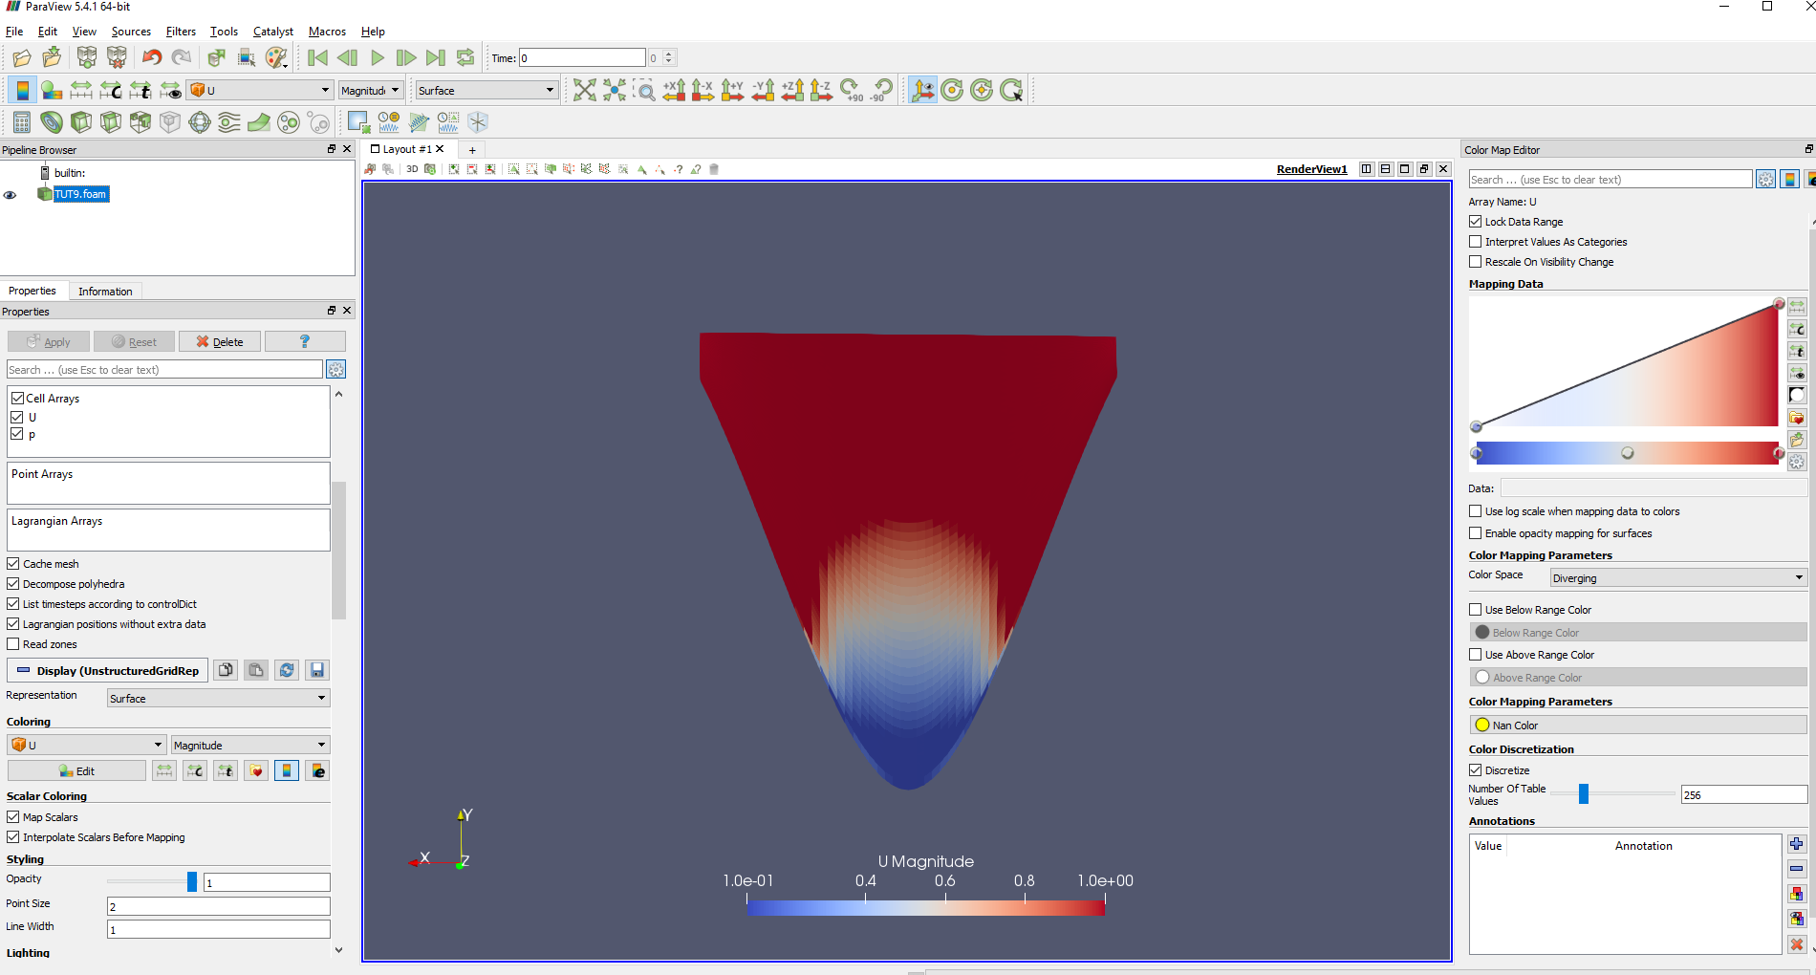

Figure 17 - Front view of original geometry velocity profile

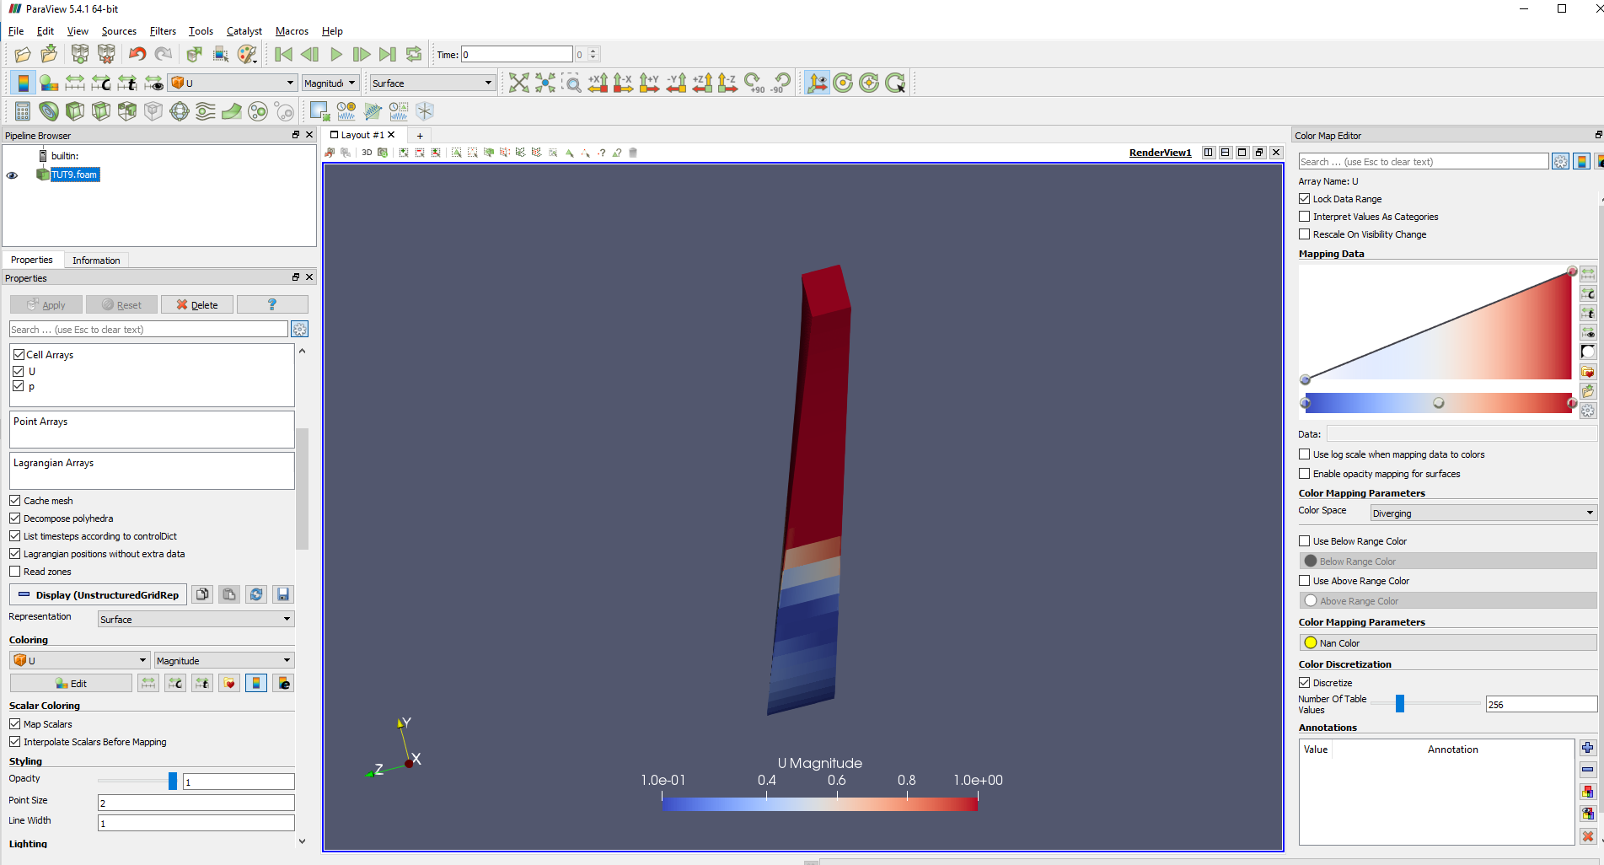

Figure 18 - Side view of original geometry velocity profile

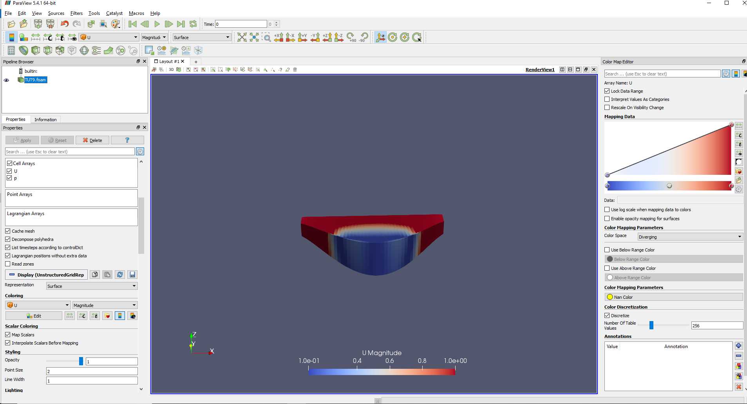

Figure 19 - Top view of orignal geometry velocity profile